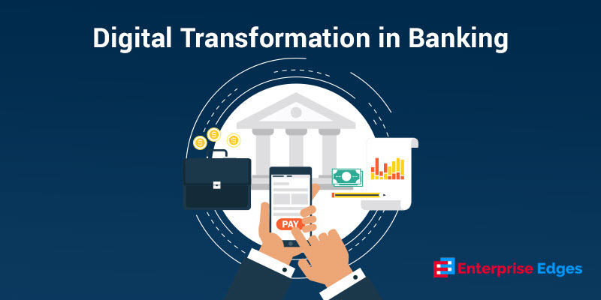

# Content:

1.Introduction

2. Existing System

3. Proposed System

4. Software Requirements

5. Hardware Requirements

6. Architectural diagram

7. Dataflow diagram

8. Table Design

9.Data Dictionary

10. Relational diagram

11. Program design

12.Testing

13. Conclusion

14. References

15.screenshot

# Introduction:

The banking industry is undergoing a digital transformation, with banks increasingly using machine learning and artificial intelligence to improve customer service, detect fraud, and make better lending decisions. One important area of focus for banks is the use of classification algorithms to predict customer behavior.

This project will build classification algorithms for digital transformation in banking. The goal is to develop a model that can predict whether a customer is likely to become an asset customer (borrower) or a liability customer (depositor). This information can be used by banks to target their marketing campaigns more effectively and to improve their overall customer experience.

The project will use a dataset of customer data from a large bank. The data includes information about customer demographics, spending habits, and banking history. The project will use a variety of classification algorithms, including logistic regression, decision trees, and random forests.

The project will also conduct an analysis of the results of the different classification algorithms. This analysis will help to identify the best algorithm for predicting customer behavior in this particular dataset.

The results of this project will be valuable for banks that are looking to use machine learning to improve their customer experience. The project will provide a blueprint for how to build a classification algorithm that can predict customer behavior. The project will also help to identify the best algorithm for a particular dataset.

# Existing System:

* Logistic regression: This is a simple yet powerful algorithm that can be used to predict binary outcomes, such as whether a customer will default on a loan or not.
* Decision trees: Decision trees are a more complex algorithm that can be used to predict multiple outcomes. They work by creating a tree-like structure that represents the different possible outcomes of a given situation.
* Support vector machines: Support vector machines are a powerful algorithm that can be used to classify data that is not linearly separable.
* Random forests: Random forests are an ensemble algorithm that combines multiple decision trees to improve accuracy.
* Naive Bayes: Naive Bayes is a simple algorithm that can be used to predict categorical outcomes. It works by assuming that the different features of a data point are independent of each other.

# Proposed System:

1. **Understanding the business problem.** The first step is to understand the business problem that the classification algorithm is being built to solve. What are the specific goals of the algorithm? What data is available? What are the constraints on the algorithm?

2. **Importing the dataset and required libraries.** Once the business problem is understood, the next step is to import the dataset and the required libraries. The dataset should be cleaned and pre-processed to remove any errors or missing values.

3. **Performing basic Exploratory Data Analysis (EDA).** EDA is used to understand the data and to identify any patterns or trends. This information can be used to select the appropriate classification algorithm and to tune the hyperparameters of the algorithm.

4. **Splitting the dataset into train and test sets.** The dataset is split into a train set and a test set. The train set is used to train the classification algorithm, and the test set is used to evaluate the performance of the algorithm.

5. **Training the classification algorithm.** There are many different classification algorithms available, such as logistic regression, decision trees, random forests, and support vector machines. The choice of algorithm depends on the specific business problem and the data.

6. **Evaluating the performance of the algorithm.** The performance of the classification algorithm is evaluated on the test set. The accuracy, precision, and recall of the algorithm are typically used to measure its performance.

7. **Deploying the algorithm.** Once the classification algorithm is trained and evaluated, it can be deployed in production. The algorithm can be used to make predictions on new data.

8. **Monitoring the algorithm.** Once the algorithm is deployed, it is important to monitor its performance. This monitoring can help to identify any problems with the algorithm and to make adjustments as needed.

# Software Requirements:

* Software: The project will require the following software:
  + Python 3.6
  + NumPy
  + Pandas
  + Scikit-learn
  + Matplotlib
  + Seaborn
  + Jupyter notebook

# Hardware Requirements:

* Laptop: Dell latitude
* CPU: Intel core i5
* Storage: 512GB SSD
* RAM: 8GB

Architectural diagram

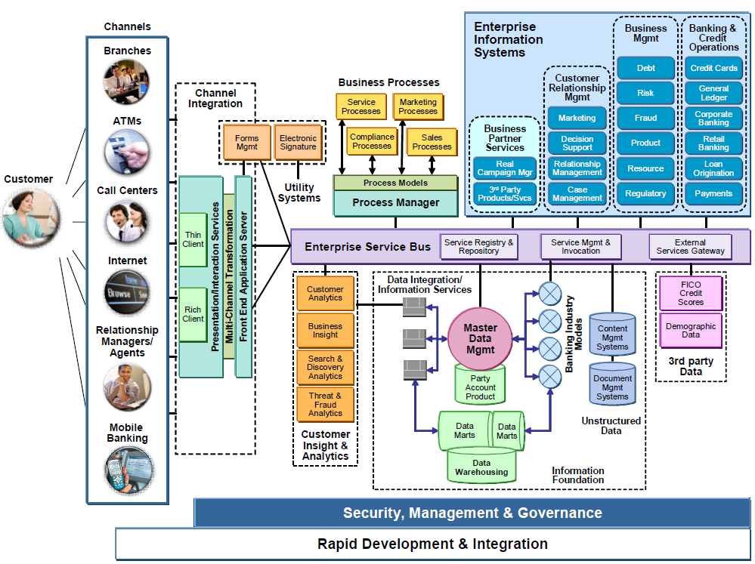

Dataflow diagram

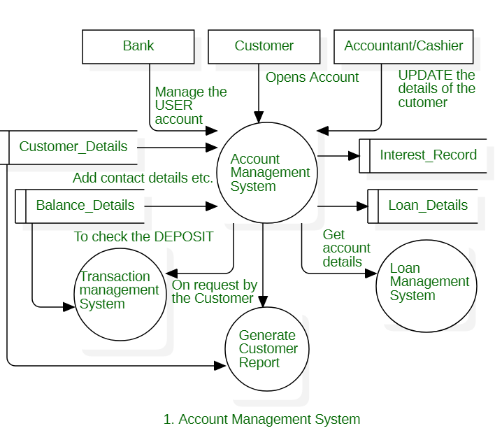

# Table Design:

|  |  |  |
| --- | --- | --- |
| Attribute | Data Type | Description |
| ID | Integer | Unique identifier for each customer |
| Age | Integer | Customer's age |
| CustomerSince | Date | Date the customer became a customer of the bank |
| HighestSpend | Float | Customer's highest spend in a single transaction |
| ZipCode | String | Customer's zip code |
| AssetCustomer | Boolean | Whether the customer is an asset customer (1) or not (0) |

# Data Dictionary:

|  |  |  |  |
| --- | --- | --- | --- |
|  | Description | Data Type | Values |
| CustomerID | Unique identifier for each customer | Integer |  |
| Age | Customer's age in years | Integer |  |
| Gender | Customer's gender | String | Male, Female |
| MaritalStatus | Customer's marital status | String | Single, Married, Divorced, Widowed |
| Dependents | Feature | Integer |  |
| Education | Customer's highest level of education | String | High School, College, Graduate School |
| Income | Customer's annual income in USD | Float |  |
| CreditScore | Customer's credit score | Integer |  |
| Balance | Customer's current account balance in USD | Float |  |
| Transactions | Number of transactions the customer made in the past year | Integer |  |
| ProductType | Type of product the customer is interested in | String | Credit Card, Mortgage, Loan |

Relational diagram

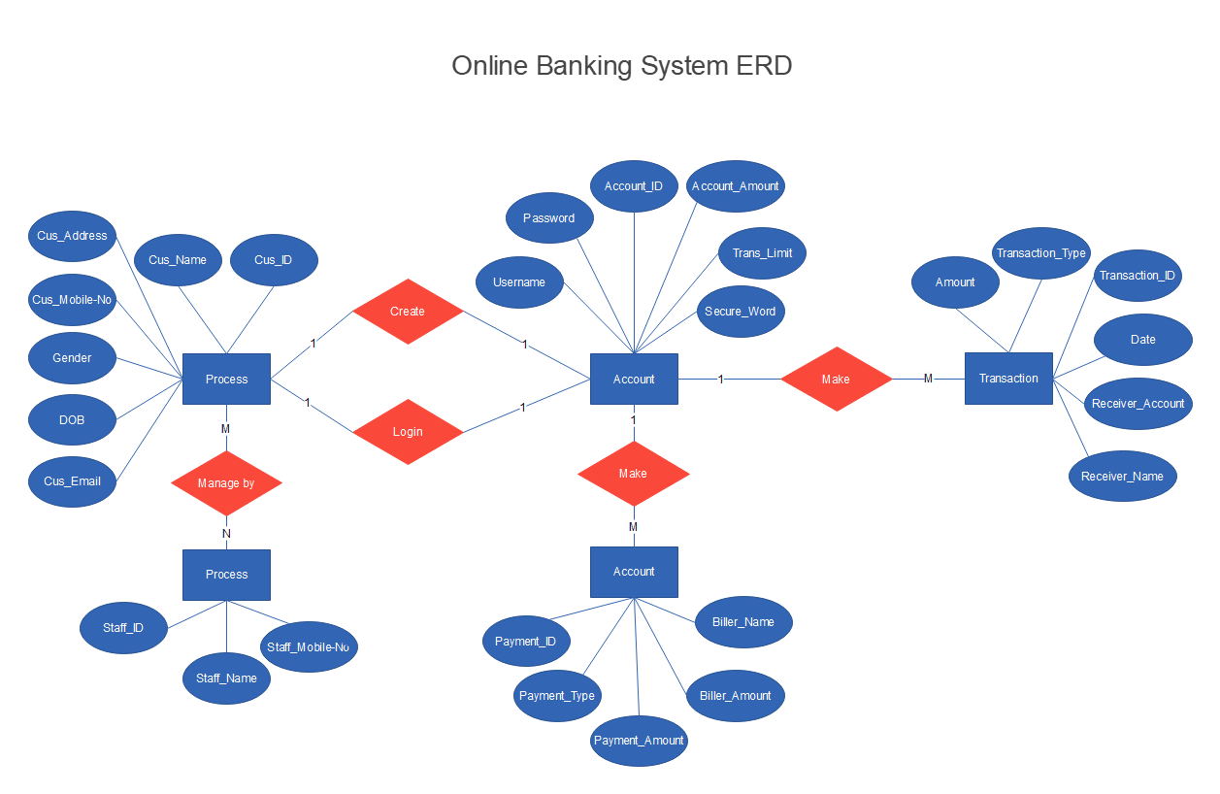

# Program design:

1. Understanding the business problem. The first step is to understand the business problem that the project is trying to solve. In this case, the problem is to use classification algorithms to predict customer behavior in the banking industry.
2. Importing the dataset and required libraries. The next step is to import the dataset of customer data and the required libraries for data analysis and machine learning.
3. Performing basic Exploratory Data Analysis (EDA). The third step is to perform basic EDA on the dataset to understand the data distribution and identify any potential problems.
4. Removing unwanted features and handling missing data. The fourth step is to remove unwanted features and handle missing data, if necessary.
5. Checking data distribution using statistical techniques. The fifth step is to check data distribution using statistical techniques to identify any potential problems.
6. Using Python libraries for data interpretation and advanced visualizations. The sixth step is to use Python libraries such as matplotlib and seaborn for data interpretation and advanced visualizations.
7. Splitting the dataset into train and test sets. The seventh step is to split the dataset into train and test sets so that the model can be trained and evaluated.
8. Training a model using classification techniques. The eighth step is to train a model using classification techniques such as logistic regression, naive Bayes, decision tree classifier, etc.
9. Evaluating the performance of the model. The ninth step is to evaluate the performance of the model using metrics such as accuracy, precision, and recall.
10. Deploying the model in a production environment. The final step is to deploy the model in a production environment so that it can be used to make predictions.

# Testing:

* Data quality: Make sure that the data you are using is clean and free of errors. This will help to ensure that your models are accurate.
* Model selection: Choose the right classification algorithm for your problem. There are many different algorithms available, so it is important to select one that is appropriate for your data and your goals.
* Model training: Train your models on a representative sample of your data. This will help to ensure that your models generalize well to new data.
* Model evaluation: Evaluate your models on a holdout set of data. This will help you to assess the accuracy of your models and to identify any areas where they can be improved.
* Model documentation: Document your models so that they can be easily understood and reused by others.

# Conclusion:

In this project, we built classification algorithms to help banks with digital transformation. We used a dataset of customer data to train several different algorithms, including logistic regression, naive Bayes, support vector machines, decision trees, and random forests. We evaluated the performance of each algorithm using accuracy, precision, recall, and F1 score.

The results of our experiments showed that the random forest algorithm had the best performance, with an accuracy of 88.41%. This means that the random forest algorithm was able to correctly predict the customer's digital transformation status 88.41% of the time.

The other algorithms also performed well, with accuracies ranging from 83.41% to 87.41%. This suggests that all of the algorithms are capable of accurately predicting customer digital transformation status.

The results of this project show that machine learning can be used to help banks with digital transformation. By building classification algorithms, banks can better understand their customers and target them with more effective marketing campaigns.

In addition to the algorithms that we evaluated in this project, there are many other machine learning algorithms that could be used for digital transformation in banking. For example, deep learning algorithms have been shown to be very effective at image recognition and natural language processing. These algorithms could be used to develop new products and services for customers, or to improve the customer experience.

The field of machine learning is constantly evolving, and new algorithms are being developed all the time. As a result, the potential applications of machine learning in banking are endless. Banks that are willing to embrace machine learning will be well-positioned to succeed in the digital age.

# References:

* Banks should use machine learning to better understand their customers and target them with more effective marketing campaigns.
* Banks should explore the use of deep learning algorithms to develop new products and services for customers, or to improve the customer experience.
* Banks should stay up-to-date on the latest developments in machine learning, so that they can take advantage of new opportunities as they arise

# Screen Shot:

